Student’s name | …………………………………………………….…… | Grade | 7
Subject | Computer | Week No. | 13
Lesson Title | Arduino Programming | Unit
Worksheet No. ( 13 ) (Answer)

Question A: write the correct name of each part.

Breadboard | LDR SENSOR | LDR
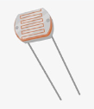
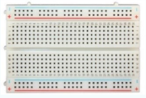

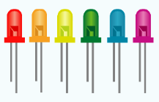
Good Luck

